DOCKER COMMANDS
Docker Image & Container Commands
- Docker run - Pull image and start container
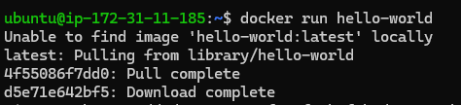
- List images
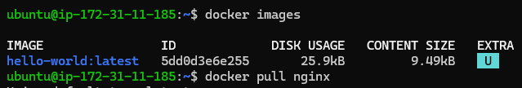
- Create nginx container named nginx and map host port to container port
- Nginx default page running in Docker container
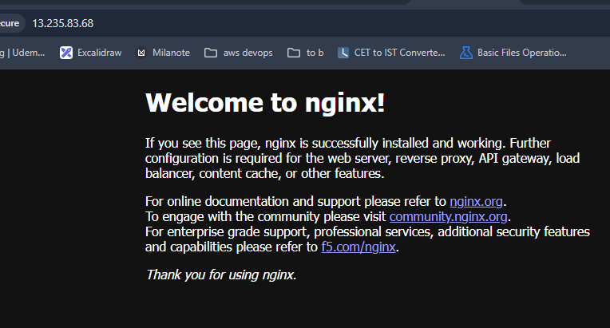
- List All containers
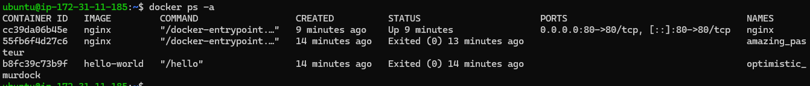
- Stop running container
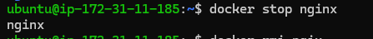
- Delete container
- Remove Image

Docker Volume commands
- Create volume
- List volumes
- Volume details
- Start container with volume attached
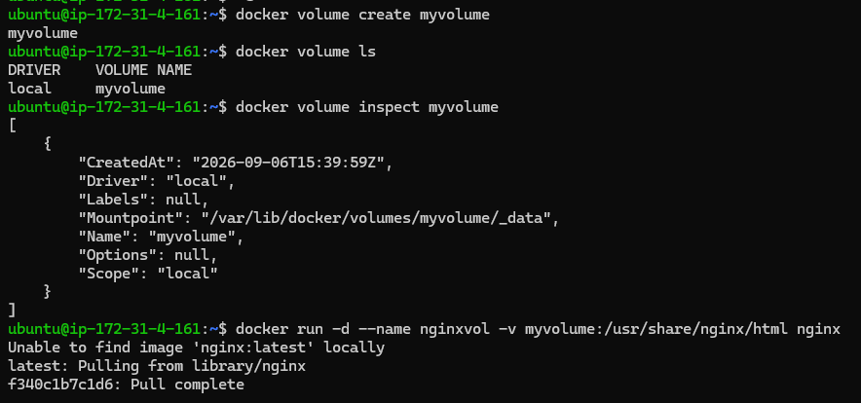
- Execute commands inside container
- Create file inside volume
- Remove volume

Docker Network commands
- Create container and network
- Attach network to existing containers
- Show Network details : 2 containers are attached
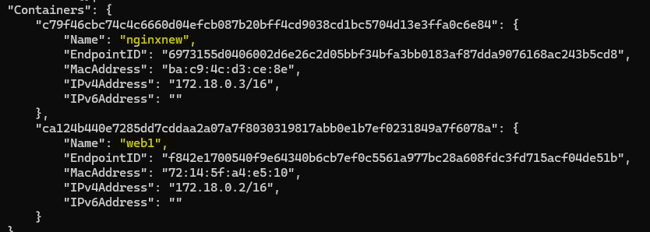
- Container with same network communicating with container name
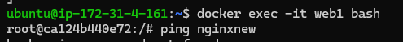
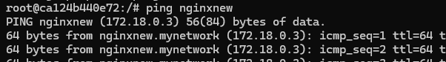
- Remove network while still attached to container = Error
- Disconnect all containers attached to network
- Remove network
- Now, containers cannot communicate between each other
